**Adding a name to a login ID**

**About this task**

To add a name to a login ID in the Dictionary:

**Procedure**

1. From the Controller window, select **Commands** > **Dictionary**.

CMS Supervisor displays the Dictionary window.



2. In the **Operations**: list, highlight **Login Identification**.

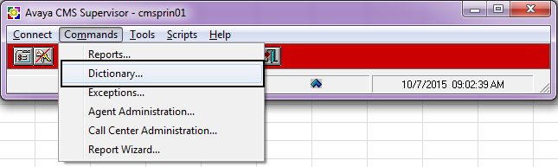

3. In the **ACD**: field, enter the ACD or ACD Group to which you want to assign a name to a

login ID.

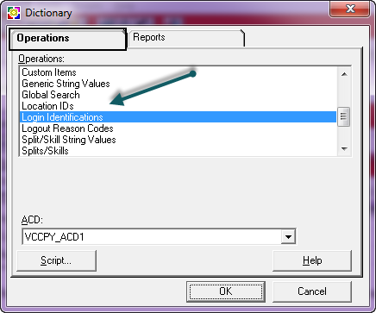

4. Select **OK**.

CMS Supervisor displays the Dictionary Login Identifications window.

5. In the **Login ID**: field, enter the number of the login ID to which you want to assign a new

name.

6. In the **Agent Name**: field, enter the name of the agent that you want to associate with the

Login ID number.

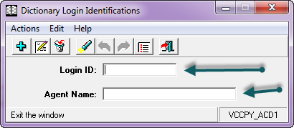

7. From the **Actions** menu, select **Add**.

